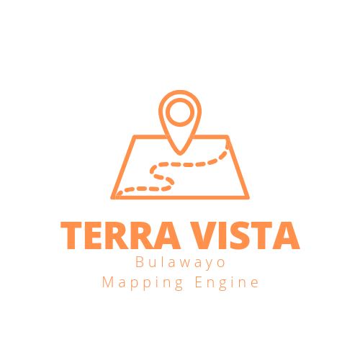

**1. Introduction**

Terra Vista meaning:

“Terra Vista” represents the essence of this mapping engine software as a powerful tool for exploring and visualizing the world. “Terra” symbolizes the Earth, highlighting the software’s focus on geographical data, maps, and spatial information. It signifies a connection to the physical world, its landscapes, and the vast possibilities for exploration.

”Vista” evokes the idea of expansive and breathtaking views. It embodies the software’s ability to provide users with a panoramic and comprehensive perspective of geographical data. It emphasizes the software’s role in presenting maps, routes, and locations in a visually appealing and user-friendly manner.

Together, “Terra Vista” encapsulates the core functionalities and purpose of the mapping engine software. It conveys the software’s mission to enable users to navigate, explore, and gain valuable insights into the world around them through intuitive and visually captivating mapping capabilities.

The word “Terra” is derived from Latin, where it means “earth” or “land.” It is a commonly used term in various fields related to geography, geology, and earth sciences.

The word “Vista” is derived from the Latin word “videre,” which means “to see” or “to view.” It refers to a scenic or extensive view, often associated with a broad or panoramic perspective. Both “Terra” and “Vista” have been widely adopted and integrated into the English language, maintaining their original meanings from Latin.

**2. Background of the app/ origins:**

Terra Vista is a mapping and surveying engine that has been developed under Northerveil Incorporated (Private) Limited in partnership with Mthoe Saps Construction Technologies. It is developed in order to help professionals in the real estate, construction, engineering and Environmental Management sector. This engine is made and optimized for Desktop, Laptop, Android and Apple Devices. The Engine comes in two forms that is PC version and Mobile app version, the engine is designed and optimized to wok for both versions.

Terra Vista mapping engine uses geospatial data, global positioning systems (GPS), satellites and satellite imagery as well as custom based research databases in order to properly map out and survey (using remote sensing) the City o f Bulawayo. It is a very powerful tool that can be applied for a variety of purposes in The Built Environment such as policy making and zonation of towns, cities as well as communal lands (by local planning authorities) and to clearly identify hotspot areas that are prime locations for profitable land development (construction projects) and real estate based projects.

The engine is designed by Mthokozisi Thabiso Sapuwa, a final year student at the National University of Science and Technology studying Property Development and Estate Management so you can trust that the engine is developed mainly for the purposes of surveying and mapping Bulawayo.

**3. How does it work and how to use it.**

Terra Vista is built using python programming and a plethora of other python API’s and libraries to make it fully functional and interactive. The source code of the engine is developed from scratch by Mthoe Saps Construction Technologies meaning each and every aspect of the engine is completely alterable to the desired outcome of the Developer thus we have full control of how the engine functions, how it is optimised and all capabilities and features are monitored by us.

The engine is built in a simple to use manner and it already has aleady managed to map over 120 low, medium and high density suburbs of Bulawayo. The engine is designed to work using an SQL database or an Excel file database this means that users if the engine can either send their excel file databases to the developer for uploading or they can have an excel file uploader which can ready the users database and then convert the data to graphically visible data through maps and graphs that the user choses to have uploaded thus the engine is completely dependent on the users data to render the needed diagrams and information to the screen.

As mentiomed the engine comes with over 200 located areas of Bulawayo thus the user will directly have access to this data and the database is also downloadable. Users will have to download this dataset and add their desired information on the rows and reupload the dataset to update the Terra Vista Bulawayo Mapping and Survey Engine in real time. This goes to show the ease of use of the sofware and also the powerful backend design of the app to be able to render these surveys and maps in real time with custom databases that can display and locate the desired users needs.

**4. What API’s does Terra Vista Bulawayo Mapping Survey Engine use?**

The software is built ontop of a number of high level programming libraries. To mention but a few of the most important ones are the use of Plotly, Streamlit, Pandas as well as Numpy and scikit-learn library. These libraries enables the Terra Vista Bulawayo Mapping Survey Engine algorithm to perform a number of high level activities and abilities such as the ability to combine GIS and Remote Sensing as well as being able to add Machine Learning (ML) and Artificial Intelligence (AI) in order to form more accurate and precise plots using this robust engine.

As much as the libraries used to build the tool are as good as they get in the technovative industry, this does not mean our engine is completely going to dependant on its current libraries and API’s for it functionality but we will continue to update the Mapping Engine and add more features to it as well by exploring other libraries that will definitely improve the functionality and usability of the engine.

This system enables superuseful information for example we will provide the most robust mapping system that enables users to locate super accurate land development sites for precise use and land development allocations. It renders database based information that the users end to the developer or can upload via the Excel file uploader in the engine in order to create robust mapping systems for their preffered land use.

**5. Gaps filled by the Terra Vista Bulawayo Mapping Survery Engine** that competitors have not fulfilled in the Bulawayo Market:

- Developing custom software that can interpret and visualize excel, csv, and other type datasets to graphically usable data.

- Developing custom software that meets the exact needs of the client and can be tailored anytime depending on the job requirements meaning software is able to handle large and robust databases and datasets.

- Breaking the barriers of land survey in Zimbabwe, this system is less labor intensive, and less time consuming. The main aim of our project is to be able to accurately draw new maps of Bulawayo (and Zimbabwe over if the project exceeds beta testing) in a short amount of time as well as providing high level technology to Bulawayo based companies and firms.